Occupation Cards:

Electrician
Avg Salary: $51,110 $4,256 per month

Public School Teacher
Avg Salary: $53,219 $4,434 per month

Waiter/Waitress
Avg Salary: $21,640 $1,803 per month
Car mechanic
Avg Salary: $39,980 $3,331 per month
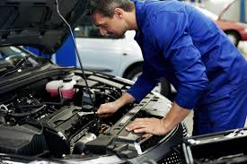

Lawyer
Avg Salary: $133,470 $11,122 per month
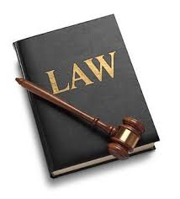

Sales Clerk at Sears
Avg Salary: $18,823 $1568 per month

Dentist
Avg Salary: $166,810 $13,900 per month

Teacher (private, Catholic school)
Avg Salary: $32,300 $2,691 per month

Meteorologist
Avg Salary: $90,860 $7571 per month

Dental Hygienist
Avg Salary: $71,520 $5960 per month

Computer Programmer
Avg Salary: $77,550 $6462 per month

Radio DJ
Avg Salary: $33,622 $2801 per month

United States Post Office employee
Avg Salary: $52,860 $4,405 per month
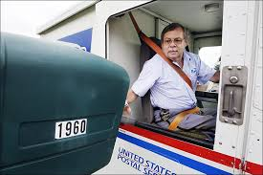

College Professor at a large university
$134,747 $11228 per month

Custodian
Avg Salary: $22,210 $1850 per month

Hair Stylist/Barber
Avg Salary: 23,120 $1962 per month

Wedding Planner
Avg Salary: $44,260 $3688 per month

Physical Therapist
Avg Salary: $83940 $6995 per month

Senior Business Analyst for Target
Avg salary: $73,245 $6103 per month

Development Director for non-profit organization
Avg Salary: $105,758 $8813 per month
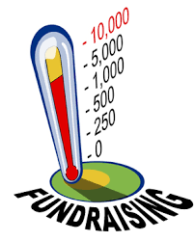

Cartographer (map maker)
Avg Salary: $50,934 $4244 per month
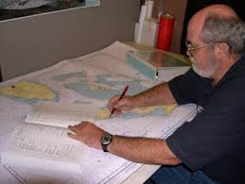

Manager at Wal-Mart
Avg Salary: $92,462 $7705 per month

Cashier at Wendy’s
Avg Salary: $16,374 $1365 per month

Construction Worker
Avg Salary: $35,750 $2979 per month

Car Salesperson (non-commission)
Avg Salary:$36,638 $3053 per month

Plumber
Avg Salary: $45,590 $3799 per month

Welder
Avg Salary: $41,949 $3495 per month

Accountant
Avg Salary: $60,978 $5081 per month

Civil Engineer
Avg Salary: $82,050 $6837 per month

Golf Course Manager
Avg Salary: $45,624 $3802 per month

Starbucks Barista
Avg Salary: $19,707 $1642 per month

Doctor (Family Physician)
Avg Salary: $165,850 $13820 per month

Newspaper journalist
Avg Salary: $38,000 $3166 per month
Life Happens Cards:

1) Flat tire. Must repair all 4 tires at once. This will be $400.

2) The neighborhood kid decides to throw a baseball through your window. This will cost $170.

3) Your refrigerator suddenly decides to stop working. You have to replace it. This will cost you $700.

4) Your car needs a new brake job. This will cost $500.

5) You ruined your clothes by mixing your dark colors with the bright colors in the washing machine. To buy new clothes you will have to spend $300 dollars

6) Your accidentally spill Hawaiian Punch all over your MacBook Pro. To replace it will cost you $12000.

7) Your lawnmower decides to quit on you. This will cost you $270.

8) Your aunt and uncle decide to make a surprise visit to your place. In order to be a good host, this will cost you around $300 for the weekend

9) You need to get a crown for one of your teeth. After insurance has paid their portion, you still owe $900.

10) Your transmission in your car needs to be replaced. This will cost you $3,000

11) Your catalytic converter needs to be replaced. This will cost you $700.

12) Your grandmother decides to send you a surprise birthday present of $200.

13) You have a leaky faucet in the kitchen and the bathroom. To replace one leaky faucet costs $217, but you have to replace two, making the total $434

14) You need to replace your fuse box. This will cost $700.

15) You drop your cell phone on the pavement leaving work and shatter the screen. This will cost you $400 to replace

16) You go out to your call and try to get it to start, but nothing. You have to get your car towed to the garage to see what is wrong with it. When you get to the garage the mechanic informs you that your alternator has just gone out. To replace the alternator will cost $600 and to have your car towed was $150. You owe $750 in all.

17) You buy two lottery tickets on your way home from work. You are the lucky winner of $500!

18) After a few weeks of having a no air conditioner in your car you decide to get it fixed. This will cost you $300.

19) After a hail storm hit your neighborhood your car’s windshield is now destroyed. You have to pay $300 to put a new windshield in.

20) You decide to go to the casino with your cousin on a Saturday afternoon and win $800!

21) You have to get new tires put on your car, luckily you only have to put on two new tires and not four. This will cost you $220.

22) On a sunny afternoon you decide to go out and try to get some yard work done; however, you realize that your weed wacker does not work. You go out and buy a new one that will cost you $150.

23) You receive an unexpected check in the mail from the local high school’s band boosters for $100!

24) You received an unexpected check in the mail from the local high school football team’s boosters club for $100!

25) You get in a minor car accident on your way home from work. After your insurance companies pays their share, you still have to pay $250 to cover all of the charges

